Course Specialist Year 12 Test Two 2022

Student name: ________________ Teacher name: ________________

Task type: Response

Time allowed for this task: _____40______ mins

Number of questions: _____6______

Materials required: Upto 3 Calculators with CAS capability (to be provided by the student)

Standard items: Pens (blue/black preferred), pencils (including coloured), sharpener, correction fluid/tape, eraser, ruler, highlighters

Special items: Drawing instruments, templates, notes on one unfolded sheet of
A4 paper, and up to three calculators approved for use in the WACE examinations

Marks available: __41____ marks

Task weighting: _10___%

Formula sheet provided: Yes

Note: All part questions worth more than 2 marks require working to obtain full marks.

Q1 (2, 3 & 3= 8 marks)
Consider the functions and
- Determine the natural domains of .

Solution
Specific behaviours
domain of f
domain of g

- Does exist over the natural domain of ? Explain.

Solution
Specific behaviours
states range of g
states condition necessary to exist
shows that does not exist with actual subsets
Note: zero marks for not exist with no reasoning

- State the rule and largest possible domain for and its corresponding range.

Solution
Specific behaviours
states rule
states largest domain
states range

Q2 (2, 4, 1 & 3 = 10 marks)
The function is defined below for .
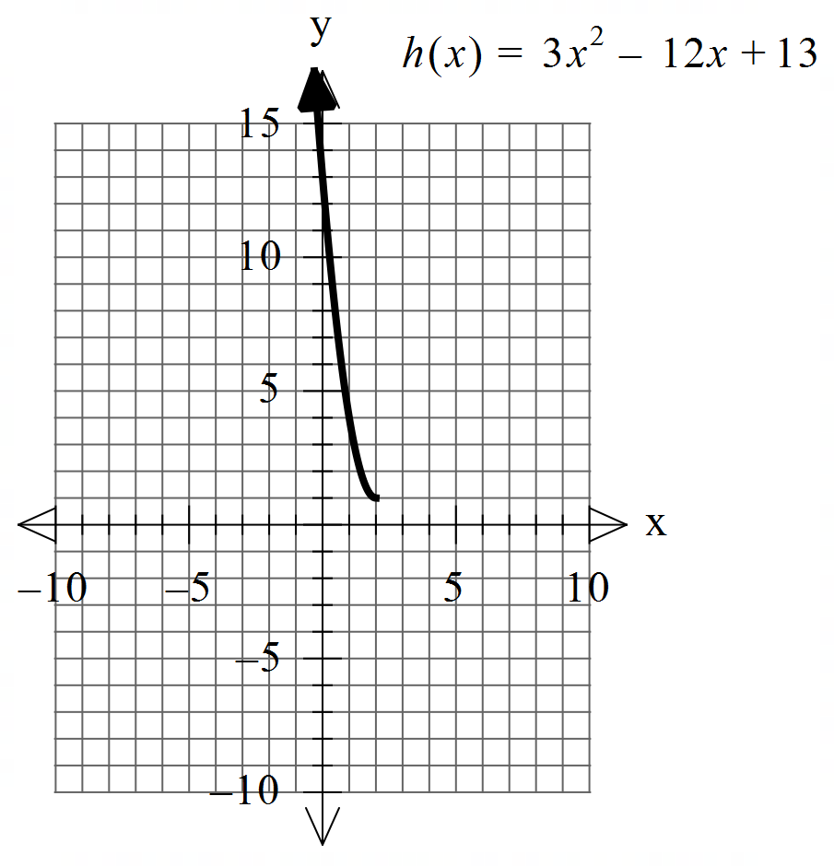

- Sketch the inverse function on the axes above.

Solution
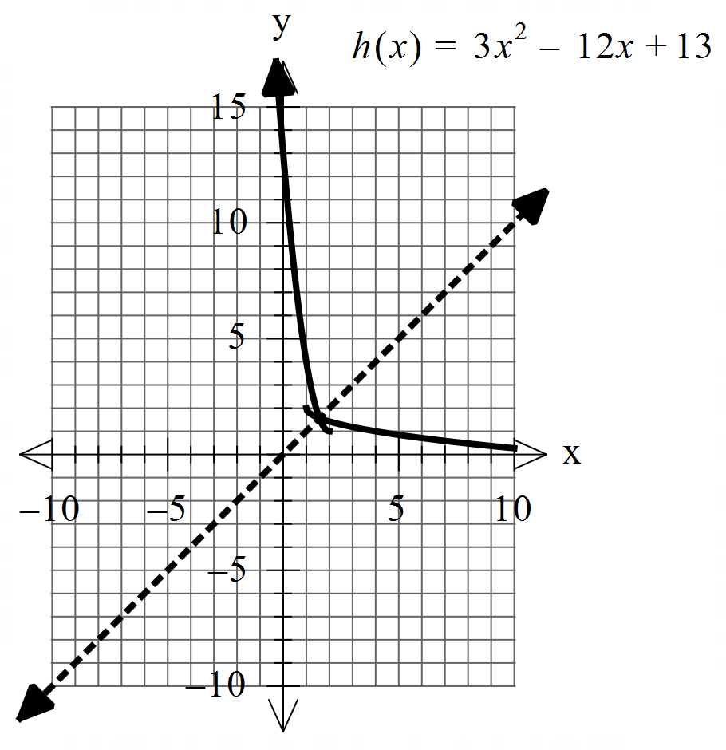

Specific behaviours
endpoint (1,2)
appears to be reflected in y=x, no need for dotted line

Q2 continued
- Determine the rule for and its domain showing full working.

Solution
Specific behaviours
states domain of inverse
shows x & y interchanged or solving for x in original function
shows two possibilities for rule
discards the positive root
Note : max 2 out of 4 if no working

- Determine .

Solution
Specific behaviours
states x

- Determine the exact coordinates (if any) for where .

Solution
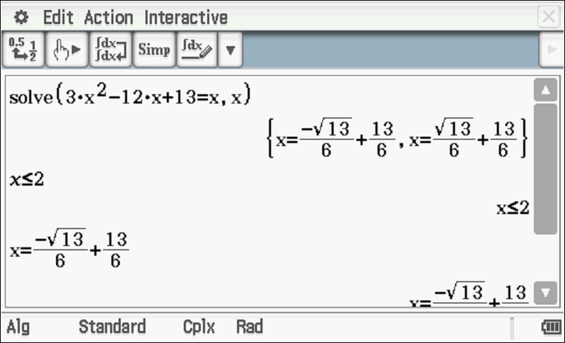
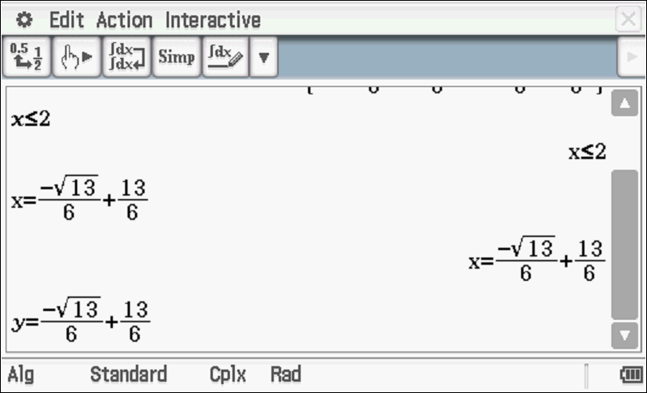
Specific behaviours
equates to x
solves for two x values
discards larger and give y coordinate

Q3 (2 & 3 = 5 marks)
Consider the function which is plotted below.
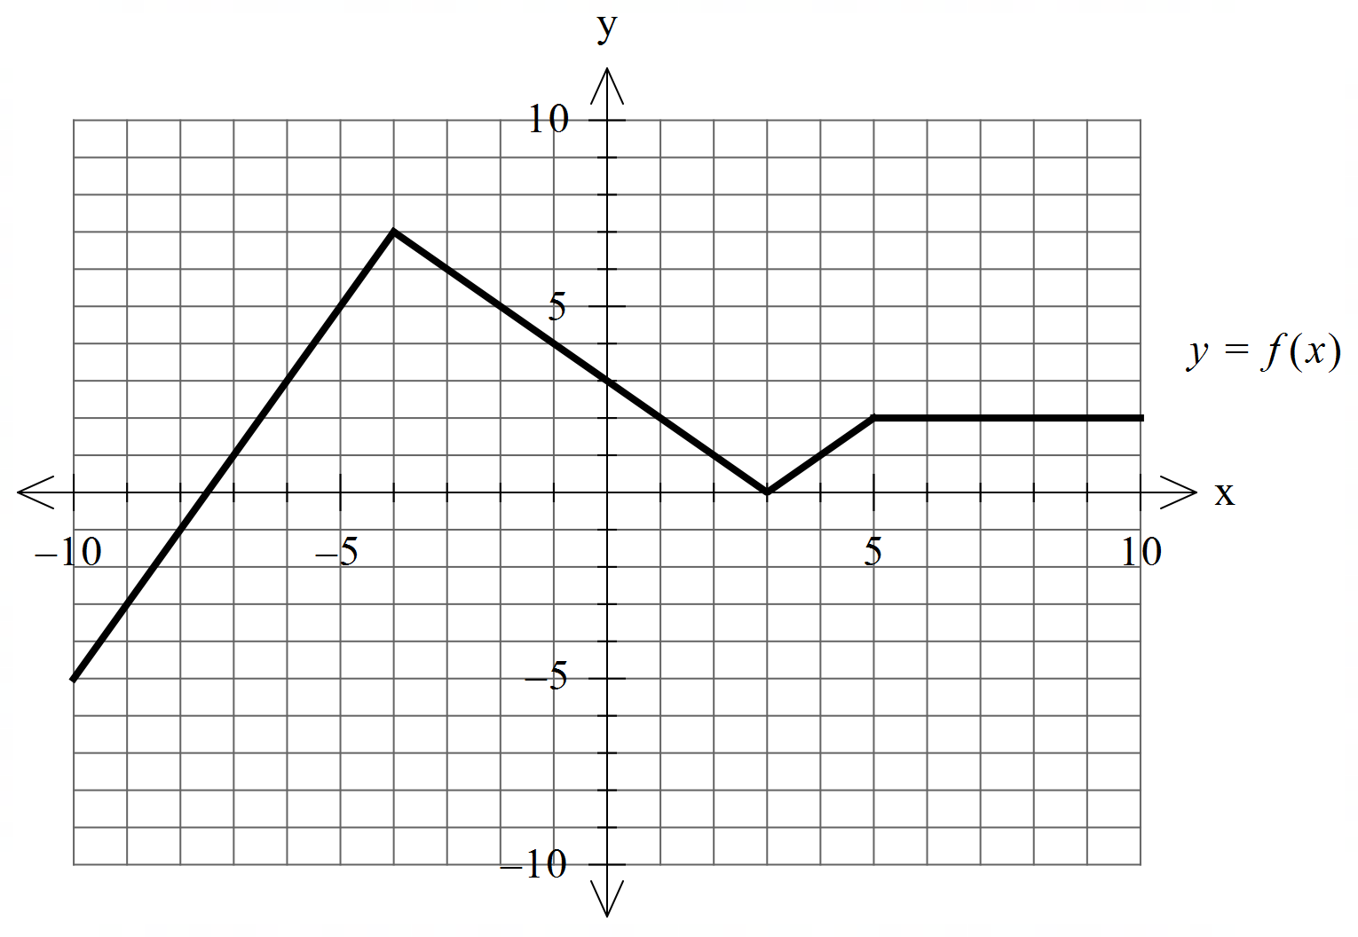


- Sketch

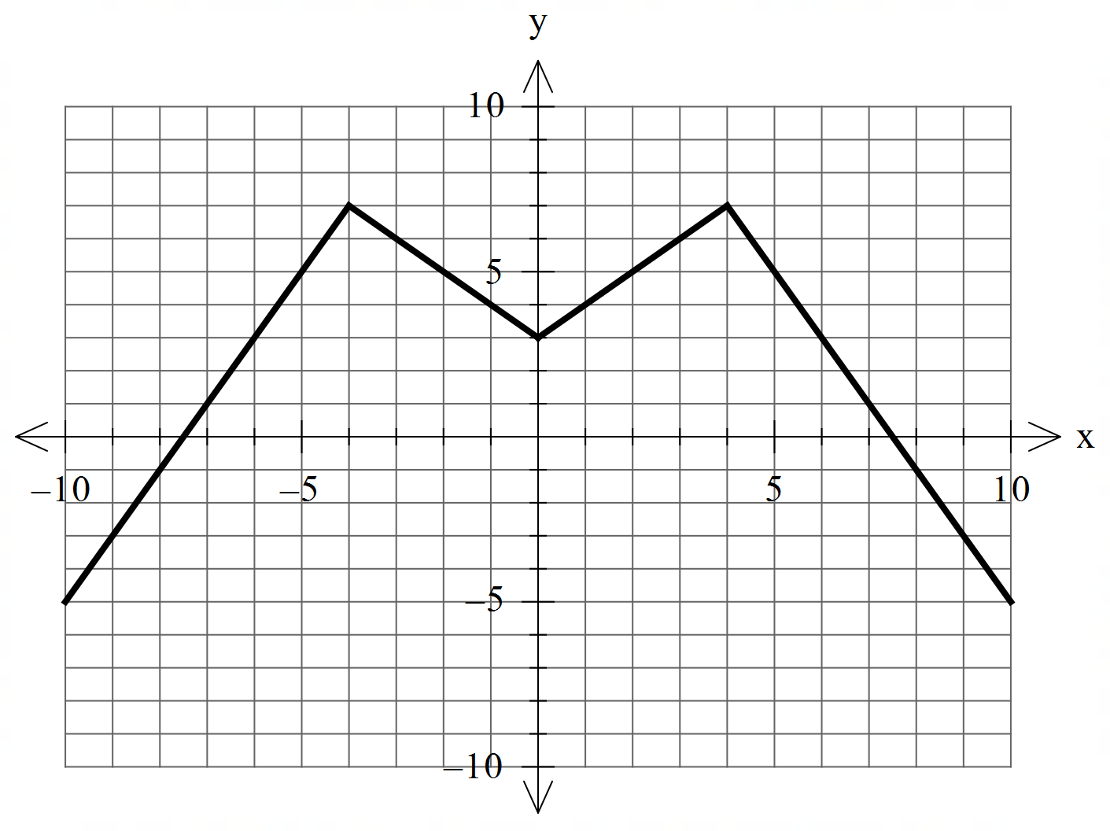

Solution
Specific behaviours
reflects left side
x & y intercepts accurate

b) Sketch
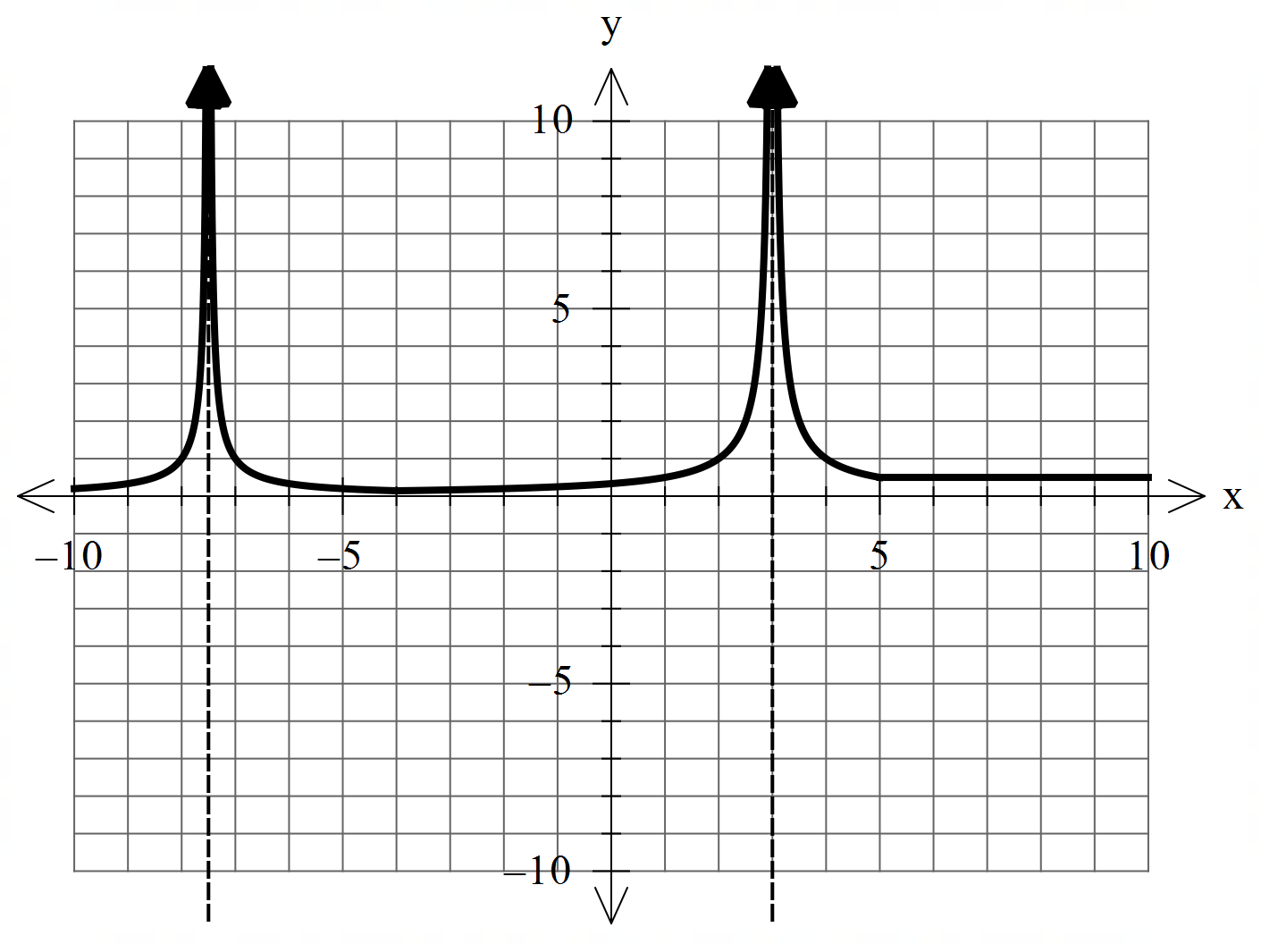

Solution
Specific behaviours
two vertical asymptotes at correct positions
shape correct between asymptotes
y=0.5 for x>5

Q4 (4 marks)
Consider two moving objects A & B such that at seconds metres and metres per second. Determine the closet approach using vector methods.

Solution
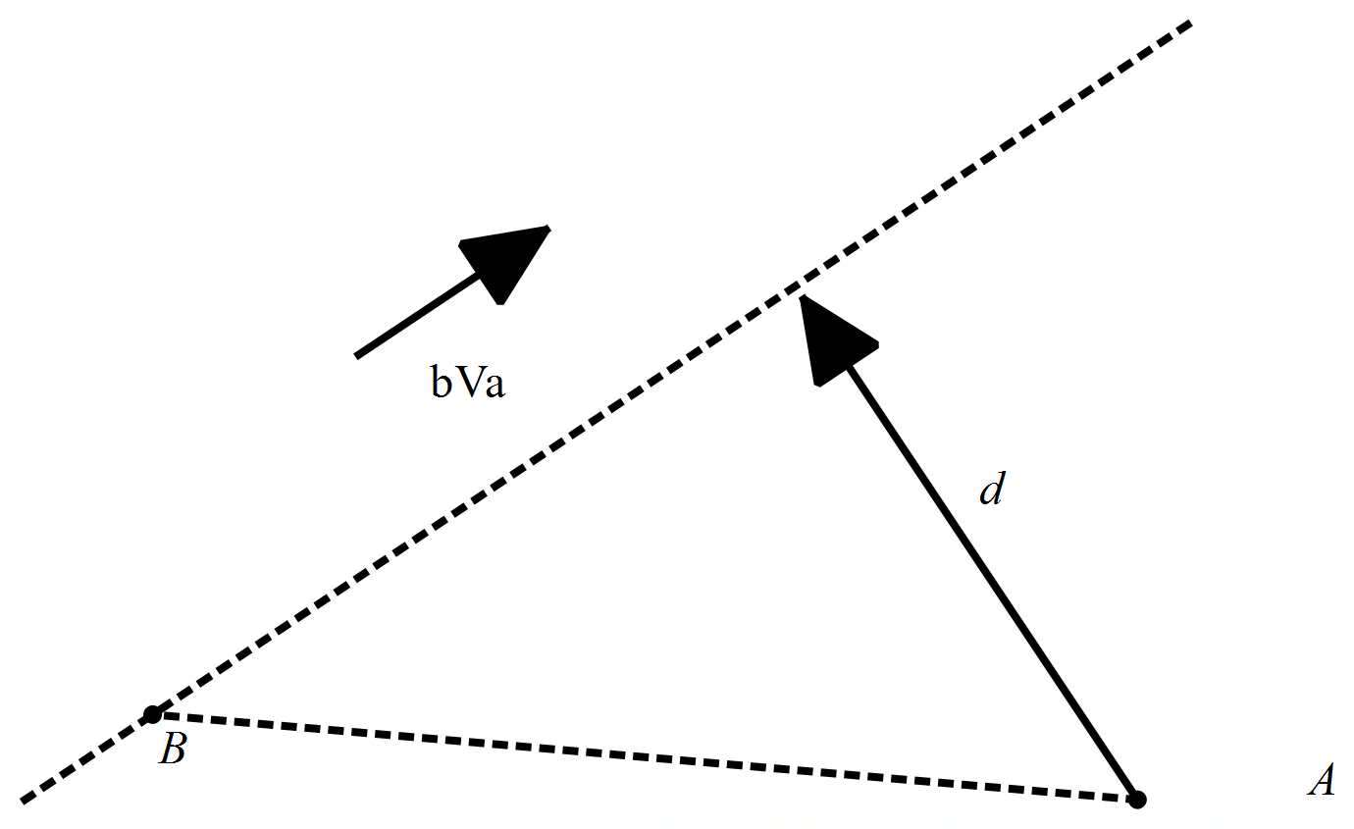

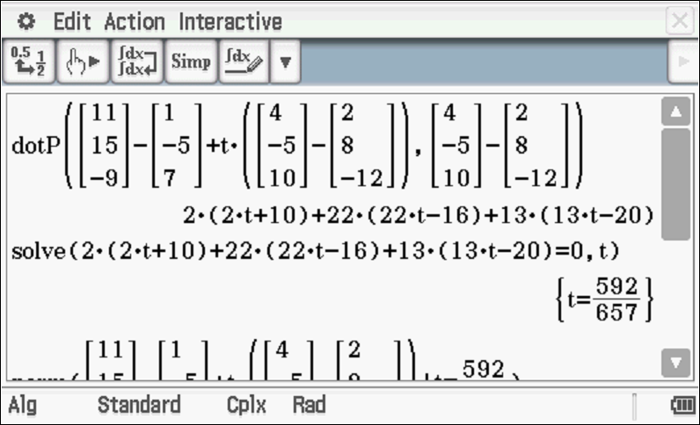
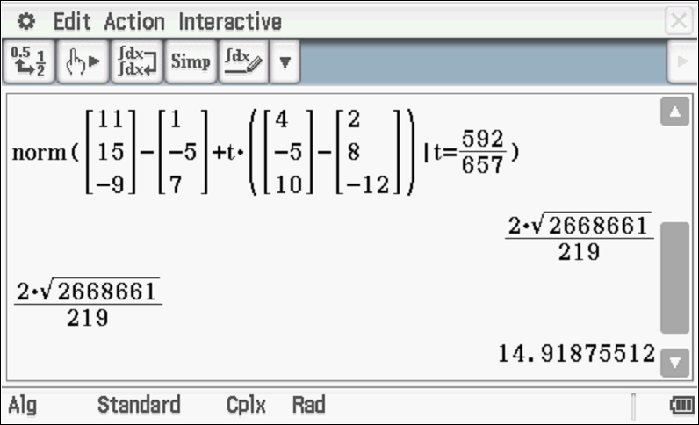

Specific behaviours
uses dot product
solves for time of closest approach
determines separation vector d
determines closest approach (approx.)

Q5 (6 marks)
Consider a sphere with a constant and the line .
Determine all possible real values of such that:
- the line meets the sphere at two pints.
- the line is a tangent to the sphere.
- the line misses the sphere completely.

Solution

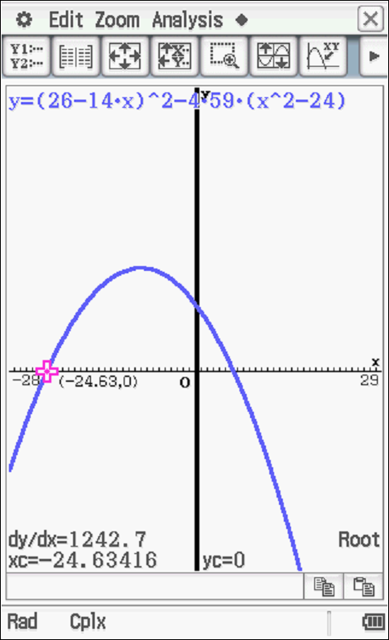 | 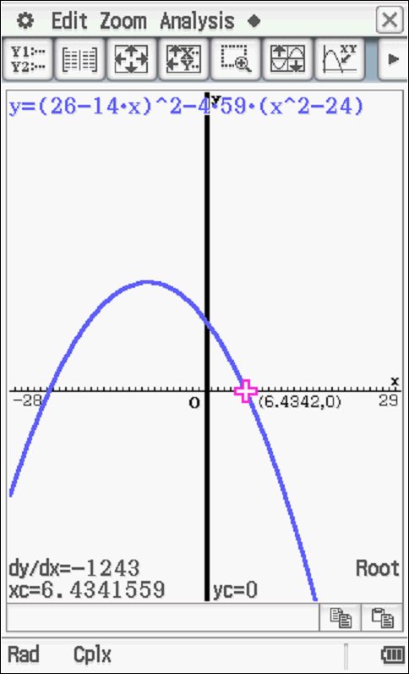

Specific behaviours
sets up an equation with both unknows
sets up a quadratic equation
obtains expression for discriminant
graphs discriminant or solves equalling zero
solves for tangent
solves for all 3 scenarios

Q6 (2, 3 & 3 = 8 marks)
Consider the plane given by .

- The point is on a plane parallel to . Determine the cartesian equation of this plane.

Solution
Specific behaviours
identifies normal
states cartesian

- Determine the distance between these two planes. Show full reasoning.

Solution

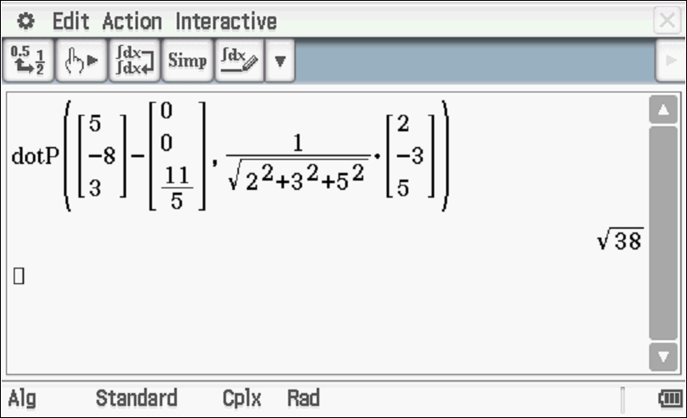

Specific behaviours
uses dot product
sets up expression for distance or subs line into vector plane equation
solves for distance, accept approx.
Note- formula used with derivation max 1 out of 3

- Consider the lines and . Determine the distance between these lines.

Solution
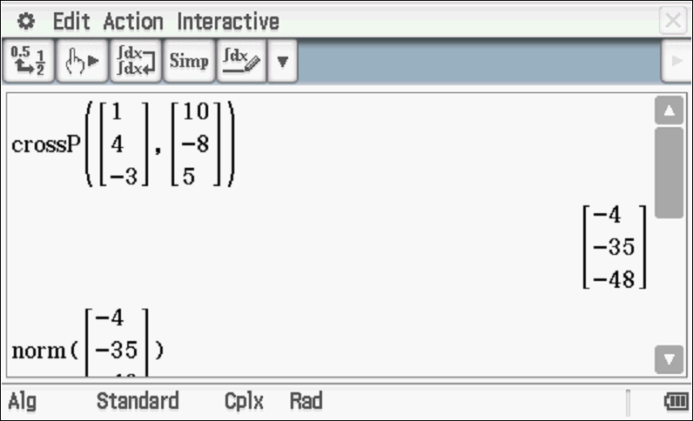
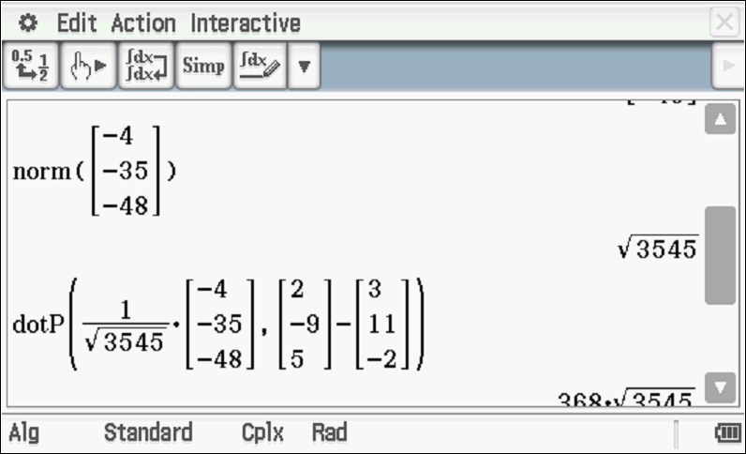
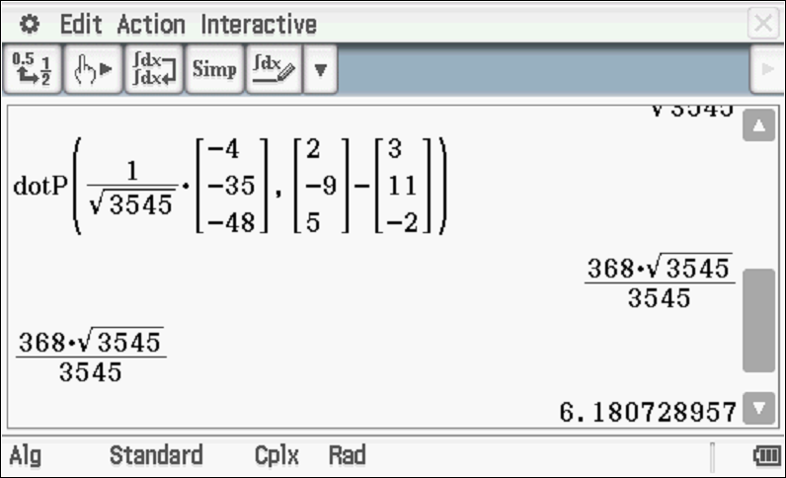
Specific behaviours
determines normal vector to both planes
uses dot product with normal
determines approx. distance
Note: zero marks if closest approach method is used

Extra working space

